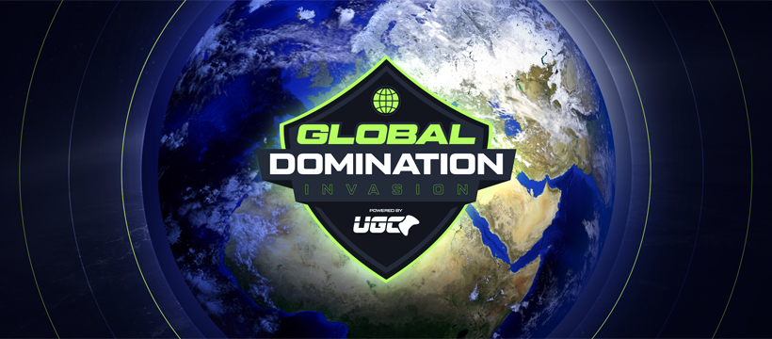

**GLOBAL DOMINATION: INVASION 2025**

**FACT SHEET**

**WHAT:** Counter-Strike 2 Worldwide Competition Series

**WHY:** $300,000 Territory Online Qualifiers

$1,000,000 Live Championship in Oklahoma City

**WHEN:** **May 14 - June 15:** Tournament Sign-up

**June 17 - July 30:** Online Territory Tournaments (Americas | Europe | Asia)

**August 29 - 31:** Live Championship at OKC’s Paycom Center

**HOW:** Register at: [www.gdinvasion.com](http://www.gdinvasion.com)

$20 Per Player | $90 Team Rate

**OVERVIEW:**

**Global Domination: Invasion** is a massive Counter-Strike 2 competitive event series, where the best amateur and professional CS2 players from around the world will compete for a piece of a **$1 Million** prize pool through a series of online qualifiers and a three-day live finale at Oklahoma City’s Paycom Center this August. The live event will feature fierce esports competition and performances by today’s hottest bands.

**Global Domination: Invasion** is spearheaded by the esports veterans at Ultimate Gaming Championship and live event producers Andy Horne and Brian Crouch.

**FACTS:**

* **Counter Strike 2 Tournament For All: *Global Domination Invasion*** is open to all players of all skill levels - always wanted to compete? This is your opportunity!
* **Come as You Are:** No requirements, no league ranking, no guild association needed. Single entrants will be matched to a team.
* **Gold, Silver & Bronze Tiers**: Players will be separated into three tiers during the group stage, determined by Steam stats, assuring first time entrants play within their skill levels. Succeed in Silver and Bronze to move up a tier.
* **The Esports Event of the Summer:** Expected audience of 10,000 fans at the Live Championships in Oklahoma City
* **Oklahoma City Live Championships:** 
  + August 29-31, 2025
  + Paycom Center (Oklahoma City, home of the OKC Thunder!)
  + Live entertainment featuring today’s hottest bands
* **Substantial Prize Pools, Sweeping Payouts**:Ample opportunity to make some bank … more than just the top teams earn prize money!
  + $300,000 Territory Finals Prize Pool ($100,000 per region)
  + **$1,000,000 Live Championships Prize Pool** (split between top 8 teams)
* **Official Partners:** AMD, Twitch, Paycom, Mammoth Live